THE WHEEL OF LIFE
Introduction
When you live a busy life and have to keep all the plates spinning in the air, it might be difficult to keep focused on the important areas of your life. While you need to have drive and focus if you are going to get things done, taking this too far can lead to frustration and intense stress.
Using the Wheel of Life tool will help you to take a "helicopter view" of your life, so that you can bring things back into balance and realise which areas of your life need immediate attention, what you need to focus on, where to put your energy and what to start from.
How to get ready
- Find a time and space where you can focus and be free of interruptions – this is your time
- If you want, get yourself a nice cup of tea or a beverage of your choice - a glass of wine is probably not the best choice ;-)
- Print out the template on page 3
- Open yourself to possibilities
- Enjoy the process
Note: You can do this all at one time or over the course of several days - and you can also check in on it on a regular basis.

Instructions
- Put your name in the centre
- Identify 8 key areas of your life:
Identify a number of key areas in your life that are important to you and select the 8 most important for you right now.
You can use the list of possible areas below or add something different.
- Family
- Partner
- Friends
- Career / Business
- Professional Development
- Work/life balance
- Finances
- Time management
- Health and Fitness
- Fun / Adventure
- Leisure time
- Travel
- Social life
- Personal Growth and development
- Spirituality
- Contribution / Giving back
- Environment
- …..?

- Using the following template add your key areas.

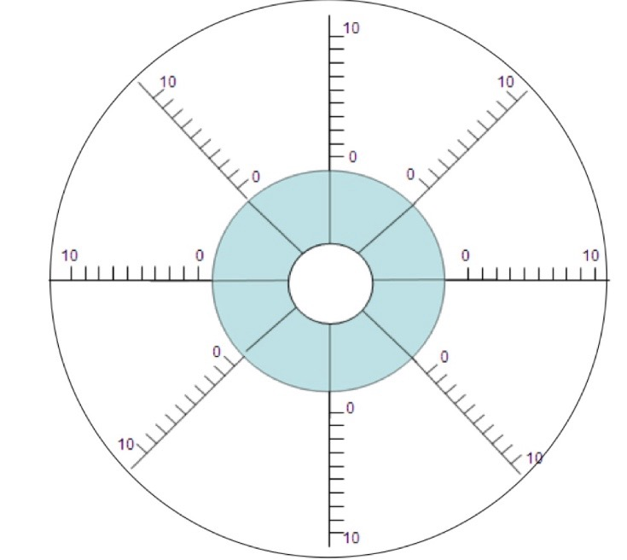

- For each area you have chosen rank your current level of satisfaction with that area from 0 (low) to 10 (high). Put your score in the box for the area. Then draw a curved line in each area to create a new outer edge.
The new perimeter represents the wheel of your life.

